Capstone Project

Team 4: FHIR Healthcare Analytics & Insurance Recommendation System
The FHIR Healthcare Analytics & Insurance Recommendation System is an educational capstone project that uses standardized healthcare data (FHIR) to derive meaningful insights into population health, patient risk assessment, and personalized insurance recommendations. This document provides comprehensive project documentation covering requirements, architecture, analytics, API design, role-based access, and system logic.
Problem Statement
Healthcare systems generate large volumes of patient data, but this data is often underutilized for deriving actionable insights at both the population and individual level. Key challenges include:
- Lack of visibility into disease trends across age groups and geographic regions
- No structured evaluation of individual patient health risk
- Generic insurance plans without personalization
- Patients and administrators lack data-driven decision tools
There is a need for a system that efficiently analyses clinical data, identifies health patterns, computes individualized risk scores, and recommends suitable insurance options.
Project Scope & Features
Core Features:
- FHIR data ingestion
- Population health analytics (disease distribution, age & location trends)
- Observation (vitals) analytics
- Medication usage analytics
- Rule-based risk scoring
- Patient similarity analysis
- Personalized insurance recommendation
- Role-based access control (Admin vs Patient)
High-Level Architecture
- Frontend: React (simple, plain UI)
- Backend: Flask (APIs, analytics logic)
- Database: MongoDB (processed, aggregated datasets)
- FHIR Server: Source of clinical data
- Auth: JWT (role-based access)
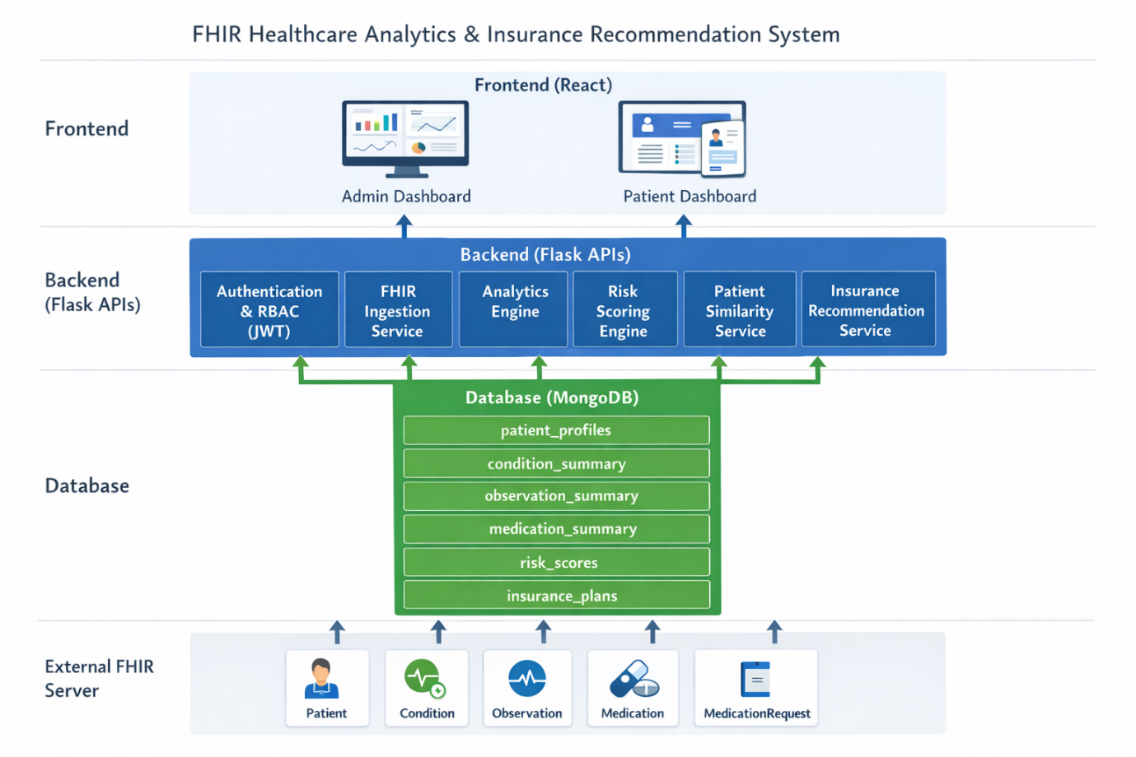
Data Flow:
FHIR Server (Patient, Observation, Condition, Medication)
↓
Backend Ingestion → Flattened data stored in MongoDB
↓
Analytics Engine (aggregation & computation)
↓
APIs (secured with JWT & Role Checks)
↓
React Frontend (Admin & Patient UX)
Role-Based Access Control
Role | Can See
Admin | Population analytics, location & age trends, chronic vs acute analytics, comorbidity trends, risk distribution
Patient | Personal risk score, personal observations, similar patient insights, personalized insurance recommendations

Analytics & Logic
1) Disease Distribution Analytics (Population Level)
What: Count of patients by disease
How:
- Group condition summary by disease
- Aggregate patient count
Data Used: Condition
Output Example:
Diabetes: 120
Hypertension: 90
Cold: 60

2) Disease Trends by Age Group
What: Which diseases affect which age groups
How:
- Define age buckets (0–18, 19–30, 31–45, 46–60, >60)
- Join patient age with condition
- Group & count
Output Example:
Diabetes → mostly in 46–60
Cold → mostly in 19–30

3) Disease Trends by Location
What: Region-wise disease patterns
How:
- Extract city from patient profiles
- Map diseases per city
- Group & count
Output:
Bangalore → Diabetes high
Chennai → Asthma high

4) Observation / Vital Analytics
What: Abnormal vitals analysis
How:
- BP >140 → High BP
- Sugar >180 → High Sugar
- Classify & aggregate by age and disease
Output:
65% diabetic patients have high BP

5) Medication Analytics (Clinical Research)
What: Medication vs disease usage
How:
- Use Medication Request to map Patient → Medication → Disease
- Flatten to medication summary
- Aggregate usage by age/disease
Output:
Metformin used by 70% diabetic patients

6) Risk Scoring Analytics (Patient Level)
What: Calculate individual health risk
How:
Risk Score = Age + Condition + Observation + Medication
Age Scoring:
- <30: 5
- 30–45: 15
- 46–60: 25
- 60: 30
Condition Scoring:
- Diabetes: +15
- Hypertension: +10
- Heart Disease: +20
- Comorbidity bonus: +10
Observation Scoring:
- High BP: +10
- High Sugar: +10
Medication Scoring (Optional):
- Long-term: +10
Risk Levels:
- 0–30: LOW
- 31–60: MEDIUM
- 61–100: HIGH
Output:
Risk Score: 72 → HIGH

7) Patient Similarity & Insurance Recommendation
What: Find similar patients and recommend best insurance plan
How:
Similarity Criteria:
- Same age group
- Same risk level
- Common condition(s)
Insurance Logic:
- LOW → Basic
- MEDIUM → Standard / Gold
- HIGH → Gold / Premium
Check plans used by similar patients, then recommend with explanation.

8) Chronic vs Acute Disease Analytics
What: Classify and analyse disease types
How:
- Chronic: e.g., Diabetes, Hypertension
- Acute: e.g., Cold, Fever
Aggregate counts by age and location

9) Multi-Condition (Comorbidity) Analytics
What: Analyse multiple simultaneous diseases
How:
- Count conditions per patient
- Classify as single vs multi-condition
Aggregate by age and risk

APIs Overview
Authentication
- POST /auth/login → JWT token (role included)
FHIR Ingestion
- POST /fhir/ingest → Populates Mongo DB
Population Analytics
- GET /analytics/diseases
- GET /analytics/disease-age
- GET /analytics/disease-location
Risk & Similarity
- POST /risk/calculate/{id}
- GET /similarity/{id}
Insurance
- GET /insurance/recommend/{id}

FHIR Entities
- Patient
  - Demographics (age, gender, location)
  - Reference for all clinical data
- Condition
  - Diseases and diagnoses associated with patients
- Observation
  - Clinical measurements (BP, blood sugar, vitals)
- Medication
  - Details of prescribed medications

Application / Database Entities
- User
  - Login credentials and role (Admin / Patient)
- Patient Profile
  - Flattened demographic data for analytics
- Risk Score
  - Computed health risk score and risk level
- Insurance Plan
  - Available insurance coverage options
- Insurance Recommendation
- Patient-specific plan recommendation with explanation

UAT Scenarios and Test Cases
A. Authentication & Role-Based Access – UAT Cases
UAT ID | Scenario | Acceptance Criteria | Expected Result | Status
UAT-AUTH-01 | User login with valid credentials | User enters correct username and password | JWT token generated and user logged in | Pass/Fail
UAT-AUTH-02 | Role-based dashboard access | Admin and Patient login | Admin sees population analytics, Patient sees personal insights | Pass/Fail
UAT-AUTH-03 | Invalid login attempt | User enters incorrect credentials | Login denied with error message | Pass/Fail
UAT-AUTH-04 | Unauthorized API access | Patient accesses admin analytics API | Access blocked with authorization error | Pass/Fail

B. FHIR Data Ingestion – UAT Cases
UAT ID | Scenario | Acceptance Criteria | Expected Result | Status
UAT-FHIR-01 | FHIR data ingestion | Valid FHIR resources submitted | Data ingested and stored in Mongo DB | Pass/Fail
UAT-FHIR-02 | Duplicate FHIR data ingestion | Same data ingested twice | No duplicate records created | Pass/Fail
UAT-FHIR-03 | Invalid FHIR structure | Malformed FHIR data submitted | Ingestion rejected with error | Pass/Fail

C. Population Health Analytics – UAT Cases
UAT ID | Scenario | Acceptance Criteria | Expected Result | Status
UAT-POP-01 | Disease distribution analytics | Admin requests disease counts | Diseases aggregated correctly | Pass/Fail
UAT-POP-02 | Disease trends by age group | Admin selects age-based analytics | Correct age-disease trends displayed | Pass/Fail
UAT-POP-03 | Disease trends by location | Admin views location-wise data | Regional disease patterns shown | Pass/Fail
UAT-POP-04 | Chronic vs acute analytics | Diseases classified correctly | Accurate chronic v/s acute counts | Pass/Fail

D. Observation & Medication Analytics – UAT Cases
UAT ID | Scenario | Acceptance Criteria | Expected Result | Status
UAT-OBS-01 | Abnormal vital detection | Observation values exceed threshold | High BP / Sugar flagged correctly | Pass/Fail
UAT-OBS-02 | Observation aggregation | Admin views vitals analytics | Aggregated statistics displayed | Pass/Fail
UAT-MED-01 | Medication usage analytics | Medication Request data processed | Medication trends shown by disease | Pass/Fail

E. Risk Scoring – UAT Cases
UAT ID | Scenario | Acceptance Criteria | Expected Result | Status
UAT-RISK-01 | Risk score calculation | Patient data available | Risk score computed accurately | Pass/Fail
UAT-RISK-02 | Risk level classification | Risk score generated | Correct risk level assigned | Pass/Fail
UAT-RISK-03 | Comorbidity handling | Patient has multiple conditions | Risk score includes bonus | Pass/Fail

F. Patient Similarity & Insurance Recommendation – UAT Cases
UAT ID | Scenario | Acceptance Criteria | Expected Result | Status
UAT-SIM-01 | Patient similarity analysis | Similar patient criteria applied | Similar patients identified | Pass/Fail
UAT-INS-01 | Insurance recommendation | Risk level evaluated | Suitable insurance plan recommended | Pass/Fail
UAT-INS-02 | Recommendation explanation | Recommendation generated | Explanation displayed clearly | Pass/Fail

G. Data Integrity & System Stability – UAT Cases
UAT ID | Scenario | Acceptance Criteria | Expected Result | Status
UAT-DATA-01 | Duplicate patient profiles | Same patient ingested twice | Duplicate prevented | Pass/Fail
UAT-DATA-02 | Concurrent analytics requests | Multiple admin users | System remains stable | Pass/Fail
UAT-DATA-03 | Performance under load | Large dataset analytics | Response within acceptable time | Pass/Fail

Recommended Analytics:

Population-Level Analytics
- Disease prevalence by age group
- Disease prevalence by city
- Chronic vs acute disease ratio
- Comorbidity distribution

Clinical Analytics
- Percentage of patients with abnormal vitals
- Medication usage by disease
- High-risk patient percentage

Risk & Insurance Analytics
- Risk score distribution (Low / Medium / High)
- Insurance plan demand by risk level
- Insurance recommendation accuracy

System Analytics
- FHIR ingestion success vs failure rate
- API response time
- Role-based API access attempts

